ASSIGNMENT 4

|  |  |
| --- | --- |
| Assignment Date | 29-10-2022 |
| Student Name | RB.SNEHA |
| Team ID | PNT2022TMID17342 |
| Project Name | Smart Farmer – IoT Smart farming Application |
| Maximum marks | 2 Marks |

Write a code and connections in wokwi for ultrasonic sensor. Whenever distance is less than 100cms send “Alert” to IBM could and display in the device recent events. Upload document with wokwi share link and images of cloud.

#include <WiFi.h>

#include <PubSubClient.h> WiFiClient wifiClient; String data3;

#define ORG "s8ov1q"

#define DEVICE_TYPE "gayathri"

#define DEVICE_ID "gayathri123"

#define TOKEN "1234

#define speed 0.034

#define led 14 char server[] = ORG ".messaging.internetofthings.ibmcloud.com"; char publishTopic[] = "iot-2/evt/Gayathri/fmt/json"; char topic[] = "iot-2/cmd/home/fmt/String"; char authMethod[] = "use-token-auth"; char token[] = TOKEN;

char clientId[] = "d:" ORG ":" DEVICE_TYPE ":" DEVICE_ID; PubSubClient client(server, 1883, wifiClient); void publishData();

const int trigpin=5; const int echopin=18; String command; String data="";

long duration; float

# dist;

void setup()

{

**Serial**.begin(115200); pinMode(led, OUTPUT); pinMode(trigpin, OUTPUT); pinMode(echopin, INPUT); wifiConnect(); mqttConnect();

}

void loop() { bool isNearby = dist < 100; digitalWrite(led, isNearby);

publishData(); delay(500);if (!client.loop()) { mqttConnect();

}

}

void wifiConnect() {

**Serial**.print("Connecting to "); **Serial**.print("Wifi"); WiFi.begin("Wokwi-GUEST", "", 6); while (WiFi.status() != WL_CONNECTED) {

delay(500); **Serial**.print(".");

}

**Serial**.print("WiFi connected, IP address: ");

**Serial**.println(WiFi.localIP());

}

void mqttConnect() {

if (!client.connected()) {

**Serial**.print("Reconnecting MQTT client to "); **Serial**.println(server);

while (!client.connect(clientId, authMethod, token))

{

**Serial**.print("."); delay(500);

} initManagedDevice();

**Serial**.println();

}

}

void initManagedDevice() {

if (client.subscribe(topic)) {

// Serial.println(client.subscribe(topic)); **Serial**.println("IBM subscribe to cmd OK"); } else {

**Serial**.println("subscribe to cmd FAILED"); }

}

void publishData()

{ digitalWrite(trigpin,LOW); digitalWrite(trigpin,HIGH); delayMicroseconds(10); digitalWrite(trigpin,LOW); duration=pulseIn(echopin,HIGH); dist=duration*speed/2; if(dist<100){

String payload = "{\"Alert Distance\":"; payload

+= dist; payload += "}";

**Serial**.print("\n"); **Serial**.print("Sending payload: "); **Serial**.println(payload);

if(client.publish(publishTopic, (char*) payload.c_str())) {

**Serial**.println("Warning crosses 110cm -- it automaticaly of the loop"); digitalWrite(led,HIGH);}

} if(dist>101 && dist<111){

String payload = "{\"Normal Distance\":"; payload

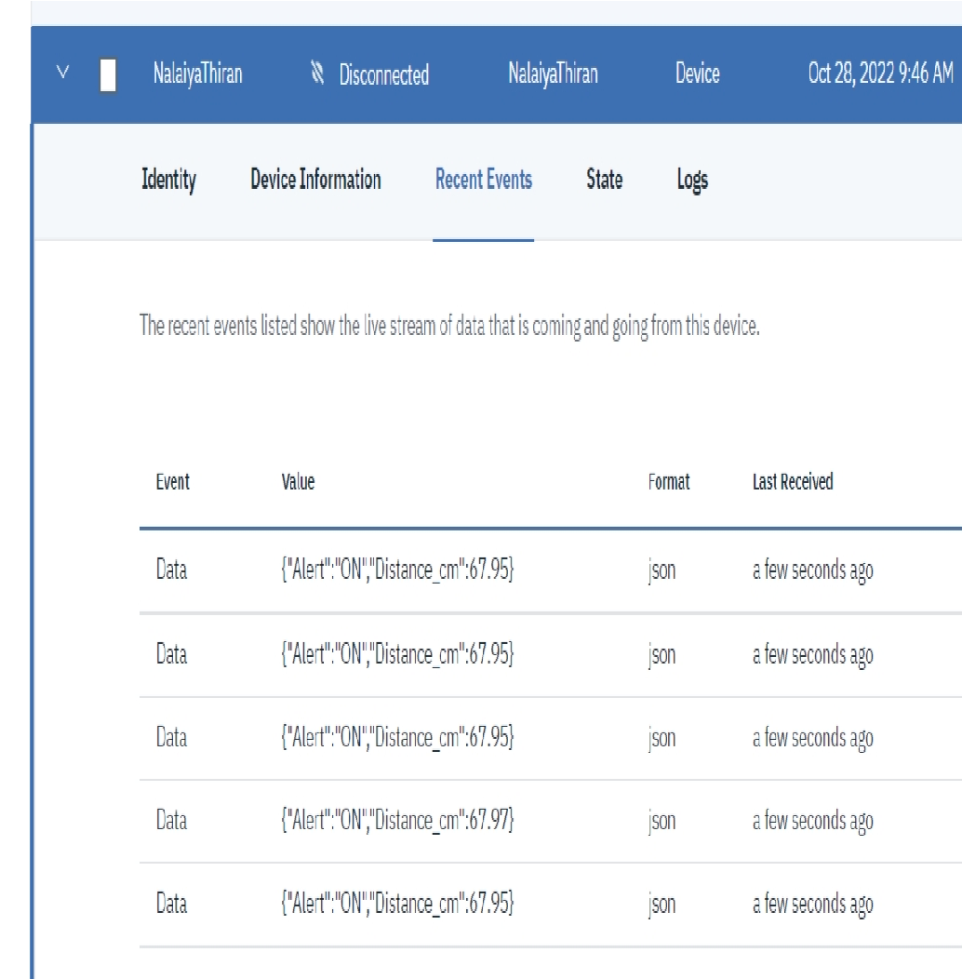+= dist; payload += "}";

**Serial**.print("\n");

**Serial**.print("Sending payload: ");

**Serial**.println(payload);

} }

void callback(char* subscribeTopic, byte* payload, unsigned int

payloadLength){

**Serial**.print("callback invoked for topic:"); **Serial**.println(subscribeTopic); for(int i=0; i<payloadLength; i++){

dist += (char)payload[i];

}

**Serial**.println("data:"+ data3); if(data3=="lighton"){ **Serial**.println(data3); digitalWrite(led,HIGH);

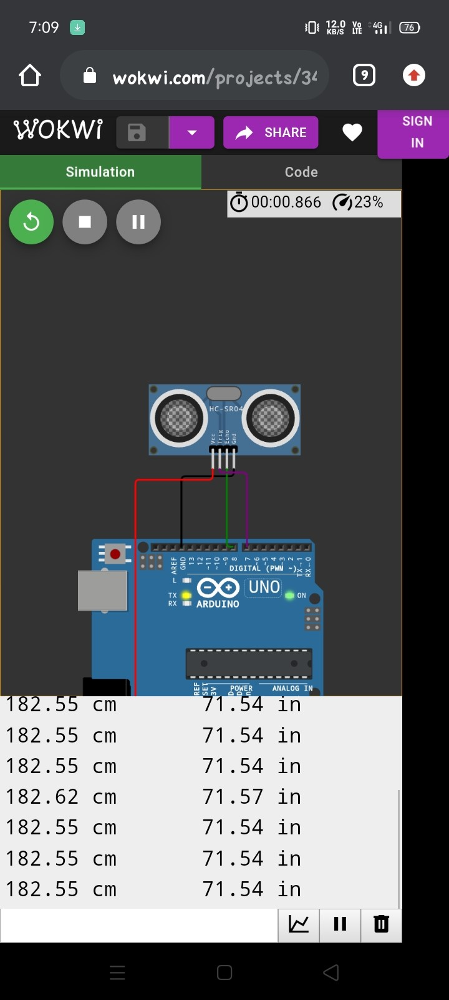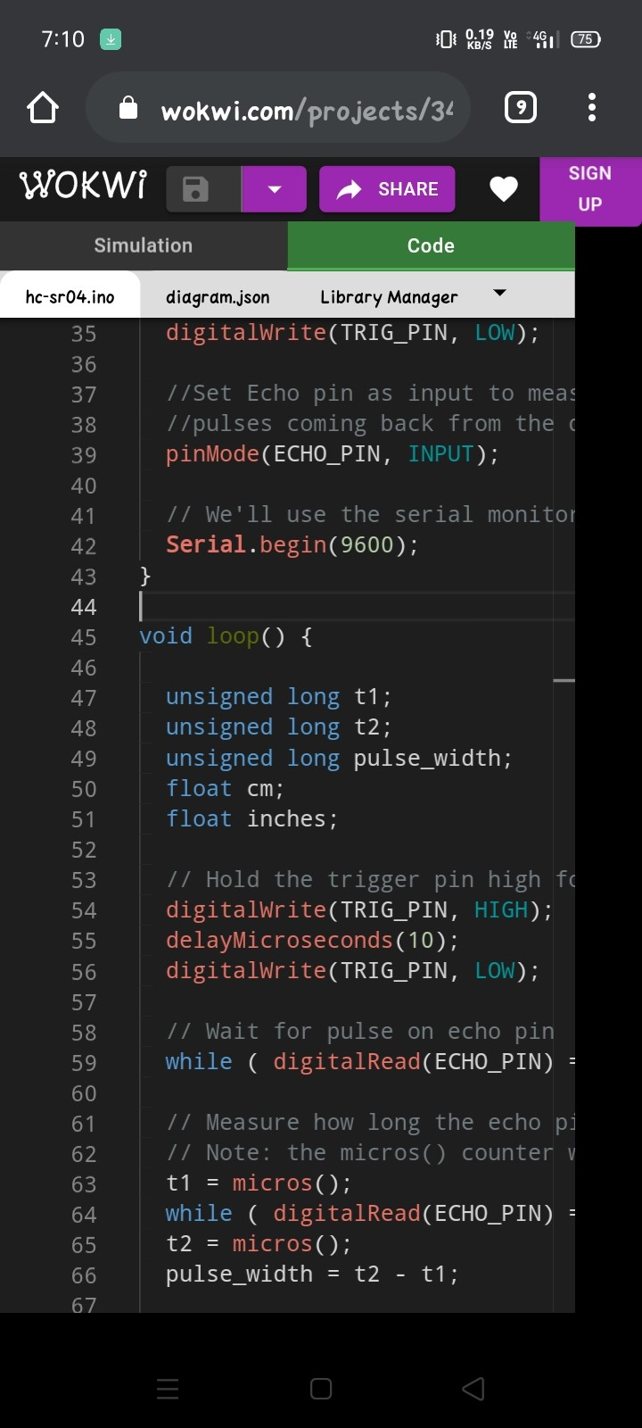} data3=""; }